***Autumn 2***

This half term we are focusing on healthy eating and food preparation in DT alongside our work on the digestive system in Science. The children should now have their logins for Maths Flex and TT Rockstars. If you are unable to access either of these, please give me an email and I can send over a spare copy. Our PE days remain Tuesday and Thursday afternoon this term.

Mr Pickavance

**Geography**

To name the different regions of Great Britain

Know the compass points North, South , East and West and use these to describe positions of countries and regions.

Identify the capital cities of European cities and label these on a map

Understand the key rivers and mountain ranges in Europe

Understand that most of Russia’s land is in Asia but the majority of the population are in Europe

Identify the topographic features of Europe

Identify the Human features of Europe

Research a country in Europe and identify geographical features

**DT**

To understand what makes a healthy diet

To recognise the amount of salt and fat in foods and what makes them unhealthy for us.

Identify saturated and unsaturated fats and which are unhealthy

To read a recipe and write instructions

To knead dough and identify how to prepare it for baking

To understand basic hygiene rules and follow these in the kitchen

To prepare a pizza and the ingredients being used

To evaluate what we have made

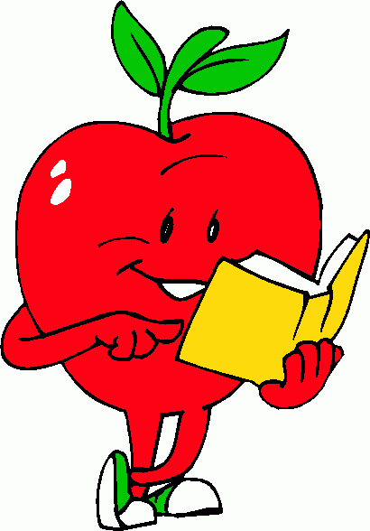

**ICT: Sound (linked to Music sessions)**

To input audio onto a device using a microphone

To play audio via an output device such as speakers or headphones

To identify the ownership of audio files

To use programs to record and produce audio clips for a purpose

To understand what a podcast is and how they are made

To evaluate the consequences of unreliable content

**ENGLISH**

To write a narrative

To write an explanation text

To use speech punctuation to show characters speaking

To use similes, metaphors and onomatopoeia for effect

To use emotions to inform how a character feels

To open sentences with fronted adverbials

To extend sentences using conjunctions: because, so, whilst, as, while

**We are Reading: The Firework Maker’s Daughter – Philip Pullman**

To continue to develop and secure:

Understand the use of vocabulary choices and the meaning of words in context.

Explain the choices of authors and infer the hidden meanings in texts.

Give detailed answers on these choices.

**SCIENCE – Digestion**

To know the process of digestion

To name the different types of teeth we have and their function in eating different foods

To understand the importance of cleaning our teeth and the effects on them if we don’t keep them clean

To identify the different organs in the digestive system and their function when breaking down food

To compare different digestive systems in animals

**French: All Around Town**

To identify different places in France

To identify different buildings and facilities found in French towns

To listen carefully to and pronounce French words accurately

To build on and develop French vocabulary

**PE**

**Dance**

Sequence a series of movements in time to music

Able to perform in time with a partner and group

Use compositional ideas in sequence such as changes in height, speed and direction

**Tag Rugby**

Pass and receive a ball

Develop attacking skills

Use space to good effect

**MUSIC: Dorset Music Enrichment Sessions**

To explain that a digital recording is stored as a file

To explain that audio can be changed through editing

To show that different types of audio can be combined and played together

To evaluate editing choices made

**RE**

Finish Topic 2: Called

The response of being chosen

Confirmation: a call to witness

Topic 3: Advent

Know and understand the gift of love and friendship

Know and understand Advent and Christmas

Christmas Performance

Practise for the Christmas performance in church

Retell the story of Christ’s birth

**RSE: Module 1 – Created and Loved By God**

Unit 1: Religious Understanding

We are created individually by God who is Love, designed in His own image and likeness

God made us with the desire to be loved and to love and to make a difference: each of us has a specific purpose

Every human life is precious from the beginning of life (conception) to natural death

Personal and communal prayer and worship are necessary ways of growing in our relationship with God

In Baptism God makes us His adopted children and ‘receivers’ of His love

By regularly receiving the Sacrament of Reconciliation, we grow in good deeds (human virtue).

**MATHS**

Unit 3: Addition and subtraction

Unit 4: Measure - perimeter

Unit 5: Multiplication and division (1)

We are focusing on our 3 and 4 multiplications this half term before adding in 10, 2 and 5 from last half term.