**DT**

We will be making and designing machines that could have been used in the making of ancient monuments, this will include:

- Identifying and using simple machines

- Making simple machines

- Designing machine prototypes

- Evaluating our simple machines to identify what went well and what could be improved

***Spring 2***

This half term we are focusing on electricity in our Science, ‘Ancient Egypt’ in our History lessons and we will be readying ourselves for Easter with the festival of Lent. We are also starting the Accelerated Reader reading system and the children will be able to select a book from our library in the range of their ability. Our PE days are back to Tuesday and Thursday afternoons.

Mr Pickavance

**History**

To know features of a civilisation

To know that the civilisations started at different times

To know archaeological finds are important because they can tell us about the materials used at the time, the skill of the craftworkers and the owners of the objects

To know Ancient Egyptian civilisation grew up around the banks of the Nile, because there was fertile soil in the floodplains.

To know Egyptian cities grew over time and were surrounded by high walls.

To know hierarchy structures in ancient civilisations

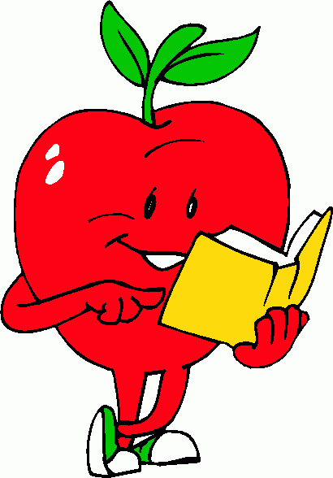

**RE**

Topic 5 Giving and Receiving

To understand giving and receiving in everyday life

Identify parts of mass: Introductory Rite, Penitential Act, Communion Rite, Concluding Rite

Topic 6 – Self Discipline

Identify the start of Lent and the religious activities around Lent

Explain how people make choices based on their religious beliefs

Recount the events of Holy Week using extracts from the Bible

Participate in a religious service

**RHE: Module 2 – Created To Love Others**

Jesus My Friend

• That God loves, embraces, guides, forgives and reconciles us with him and one another

• The importance of forgiveness and reconciliation in relationships, and some of Jesus’ teaching on forgiveness

• That relationships take time and effort to sustain

• That we reflect God’s image in our relationships with others: this is intrinsic to who we are and to our happiness

Friends, family and others

• To maintain and develop good, positive, trusting relationships; strategies for when relationships go wrong

• That there are different types of relationships including those between acquaintances, friends, relatives and family.

• A good friendship is when both persons enjoy each other’s company and also want what is best for the other

• The difference between a group of friends and a ‘clique’

• Their awareness of bullying (including cyber-bullying), that all bullying is wrong, and how to respond to bullying

• Harassment and exploitation in relationships, including physical and emotional abuse and how to respond

**MATHS**

Unit 8 – Fractions

Unit 9 – Fractions (2)

Unit 10 – Decimals

We are focusing on our 9 and 7 multiplications this half term before adding in the multiplications already learnt.

**Life Education Bus**

As part of the RSE curriculum, the life education bus will be visiting school on the 13th March. We will use this day to complete more activities with the children and

**SCIENCE – Electricity**

To identify common appliances that run on electricity.

To construct a simple series electrical circuit, identifying and naming its basic parts, including cells, wires, bulbs, switches and buzzers.

To identify whether or not a lamp will light in a simple series circuit, based on whether or not the lamp is part of a complete loop with a battery.

To recognise that a switch opens and closes a circuit and associate this with whether or not a lamp lights in a simple series circuit.

To recognise some common conductors and insulators, and associate metals with being good conductors.

**ENGLISH**

To write a recount

To write a narrative story

To write in the style of an author

We will continue to use our writing skills to write effective sentences for each genre of writing. There will be a focus on ensuring all written work is presented neatly and uses the basics taught at Key Stage 1.

**We are Reading: Charlotte’s Web – E. B. White**

We are continuing with Charlotte’s Webb this half term and will use the VIPERS to help develop our skills at developing our understanding of texts and how they are written.

We are also using the Accelerated Reader system for reading and the children will be encouraged to complete assessments online every few weeks to test their understanding of what they have read.

**PE - Netball and Football**

Apply and develop a broader range of skills, learning how to use them in different ways.

Develop an understanding of how to improve in different physical activities.

Develop flexibility, strength, technique, control and balance.

Use running, jumping and catching in isolation and combination.

Develop an understanding of how to improve in different physical activities and sports.

Work collaboratively to attack a goal.

Use and develop football skills.

Work collaboratively to play in game situations.

**ICT: Programming B**

To write algorithms to make items move

To use loops to create shapes

To identify different types of loops and how to use them in our work

To use animations in scratch to animate our names for different effects

To identify errors in algorithms and correct these

To create our own versions of games

**MUSIC**

To learn the lyrics to a song

To play instrumental parts within the song

To improvise using voices and/or instruments within the song

To perform the song learnt