Understanding the World (UW)

I will be learning about …

- different items and traditions related to Harvest, Bonfire Night, Remembrance Sunday, Hannukah and Christmas through listening to storis, watching video clips and looking at pictures on the IWB
- the story of Guy Fawkes and why we celebrate bonfire night
- the significance of Remembrance Sunday

Expressive Arts and Design (EAD)
I will be learning to...
- paint/collage poppies
- create firework pictures on black paper: splatter/chalk/glitter & glue
- Make rockets for our Firework display
- role play ‘Santa’s Grotto’ in the home corner

- respond to music from different festivals
and sing familiar Christmas songs

- make a Christmas card and a calendar for my family

Let’s
Celebrate!
Autumn2022
Maple Class

Mathematics (M)

In topic maths I will be learning to....
- use 2D and 3D shapes to create firework pictures and models
- play counting backwards games to launch our rockets
- use firework rhyme ‘5 little Fireworks’ to explore simple subtraction
- learn about the months and seasons of the year and create a calendar for my family
- create wrapping paper using repeating pattern
- make paper chains in repeating colour patters
- weigh Christmas presents and order lightest to heaviest

Physical Development (PD)
I will be learning to…
- explore movements with my body to create a firework dance
- make junk model rockets
- hold my pencil correctly and develop my hand control through tracing and copying firework patterns
- develop my finger muscles through a variety of ‘Funky Fingers’ activities

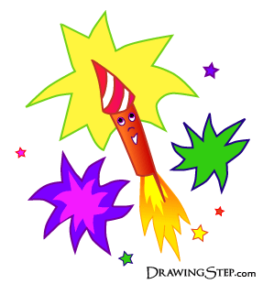

Lets
Celebrate!
Autumn 2022

Literacy (L)

I will be learning to…
- listen to stories related to special celebrations
- write letters of the alphabet with correct letter formation
- read all Set 1 sounds (individual letter sounds) in RWI
- segment and blend to read and write simple CVC words
- use phonic knowledge/wordbank to write for a purpose e.g Firework sounds, a letter to Santa
- explore meaning of new vocabulary encountered in texts ‘Room on the Broom’ and ‘Stick Man’

Personal Social Emotional Development (PSED)

I will be learning to...
.
- think about occasions/events which are special to me and others
- discuss bonfire night safety
- participate in turn taking during group games
- try new activities independently and select resources independently.
- think about my own feelings and the feelings of others

Communication and Language (CL)
I will be learning to…
- share my own experiences of Bonfire night, Remembrance Day and Christmas through class discussion, circle times and working with my Talk Partner
- explore firework vocabulary e.g. whizz, fizz, crackle
- play word games to develop my topic vocabulary e.g. pelmanism, lotto
- discuss firework safety
- re-tell the Christmas story through taking on key roles
- learn to recite poem ‘On Bonfire Night’
- retell Christmas story using small world toys and puppets

